 |  |  |  | 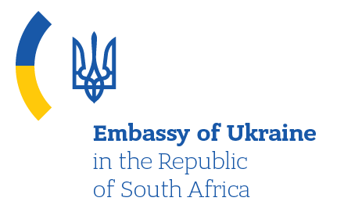
PROGRAMME
ONLINE MEETING
“UKRAINE - SOUTH AFRICA: BUSINESS OPPORTUNITIES IN TIMES OF ECONOMIC DIFFICULTIES”

Date: June 19, 2020
Venue: Ukrainian CCI (Kyiv, 33, Velyka Zhytomyrska St., ZOOM Application)

Working language: English
11:00-11:30 | OPENING SESSIONS
 | Moderator: Mr. Valeriy KOROL, Vice President of the UCCI
 | WELCOMING REMARKS
 | Mr. Gennadiy Chyzhykov |  | President of the UCCI
 | Mr. Olivier Serrao |  | CEO BUSA (Business Unity South Africa) (ТВС)
 | Ms. Liubov Abravitova |  | Ambassador Extraordinary and Plenipotentiary of Ukraine to the Republic of South Africa
 | Mr. Andre Groenewald |  | Ambassador Extraordinary and Plenipotentiary of the Republic of South Africa to Ukraine
11:30 - 12:00 | PANEL DİSCUSSİON
 | Prospects for bilateral cooperation between Ukraine and South Africa
 | Mr. Taras Kachka |  | Deputy Minister for Development of Economy, Trade and Agriculture of Ukraine – Trade Envoy of Ukraine (TBC)
 | Representative |  | Representative of the Department of Trade and Investment of SA (Name to be confirmed)
 | Mr. Volodymyr Khomanets |  | Director of Economic Diplomacy Department, Ministry of Foreign Affairs of Ukraine
 | Ms. Tetyana Miskova |  | Acting Director, State Institution “Export Promotion Office of Ukraine”
 | Ms. Olesya Loubser |  | Representative of the UCCI in the Republic of South Africa
12:00 - 12:15 | Q&A session
12:15 - 12:30 | Final remarks

