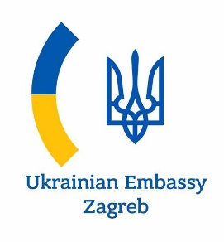
PROGRAM
ONLINE MEETING OF UKRAINIAN AND CROATIAN BUSINESS CIRCLES: PROSPECTS FOR COOPERATION IN AGRICULTURE

Date: 14 May, 2020
Venue: Ukrainian CCI (Kyiv, 33, Velyka Zhytomyrska St., ZOOM Application)

Working languages: English
13:00-13:30 | OPENING SESSIONS
 | Moderator: Mr. Valeriy KOROL, Vice President of the UCCI
 | WELCOMING REMARKS
 | Mr. Gennadiy Chyzhykov |  | President of the UCCI
 | Mr. Vasyl Kyrylych |  | Ambassador Extraordinary and Plenipotentiary of Ukraine to the Republic of Croatia
 | PANEL DİSCUSSİON
 | Prospects for bilateral cooperation between Ukraine and Croatia
 | Mr. Volodymyr Khomanets |  | Head of Economic Cooperation Department, Ministry of Foreign Affaires of Ukraine
 | Agrarian potential of Ukraine and Croatia
 | Mr. Tugomir Majdak |  | State Secretary, Ministry of Agriculture of Croatia
 | Ms. Olga Trofimtseva |  | Expert, Minister of Agrarian Policy and Food of Ukraine (2017-2019)
 | Ukrainian business perspective on cooperation with Croatia
 | Mr. Dmytro Los |  | Advisor to the CEO of MHP (Group of companies PrJSC  “Mironivsky Hliboproduct”)
 | Mr. Josip Bičvić |  | Member of the Management Board, Žito Group (Croatian Food Processing Group)
13:30 | Q&A SESSION  Ukrainian and Croatian companies, including co-organiser Mr. Berislav Čižmek – CEO, CBBS - Management Consulting & EU Lobbying Company.

